Tutorial-Assignments

Guide

December 17, 2019

Adding an Assignment Group
Before you add an assignment in the Assignments tab, you will need to add an assignment group, if you don't have an assignment group already. First, click "Add an assignment group" and type in the necessary information. Click "Save."
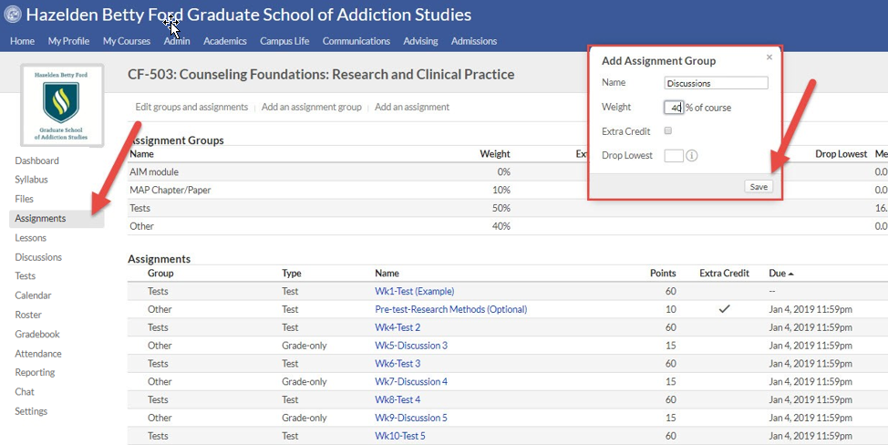

Adding an Assignment
To add an assignment, click “Add an assignment.” In the text box, write the assignment name.
Make sure you use the same naming protocol that that is used in the lesson and Activities Checklist (i.e.-Week-Assignment Name). Make sure you include the amount that the assignment is worth.

Use the drop-down menu to attach the assignment to the right assignment group. This will make sure that the assignment is weighted and organized properly. There are four main file types that an instructor may use.
- If the assignment requires the instructor to input a grade without students uploading a document, then chose “grade-only.” Such assignments may include discussion forums or participation grades.
- Decide whether students will need to submit a document, such as a paper. If so, select “File.”
- If the assignment is a test, select “Test,” this will allow you to create a window in which the test can be taken.
- If it is a discussion, chose “Discussions” for the type. This will create a “graded” discussion.
Soon, all courses will have an electronic rubric tied to each assignment. If the rubric has been created for your course (check the Rubrics tab), then identify the correct rubric. Put in the date of when the assignment is due. Make sure to put 11:59pm or midnight as the time the assignment is due.

When you are finished, click “Save.”
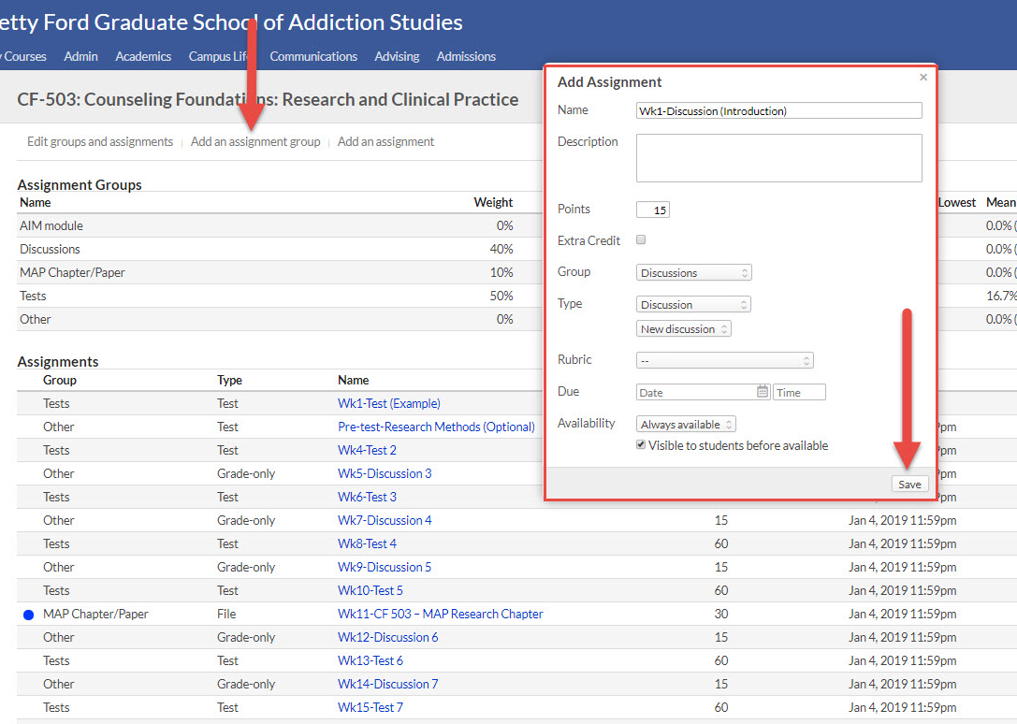
When you are finished, make sure you add this assignment to the lesson. If you need assistance on how to do so, find the Tutorial-Lessons document in the Lessons page of the support site or contact the instructional designer.

Edit an Assignment
To edit an assignment or multiple assignments at one time, click “Edit groups and assignments.” You will see that everything but the “Type” is editable. (If you need to edit the type, click on the assignment name, and edit the type to the right-hand side of the page.) Make the changes you need. Then, click “Save.”
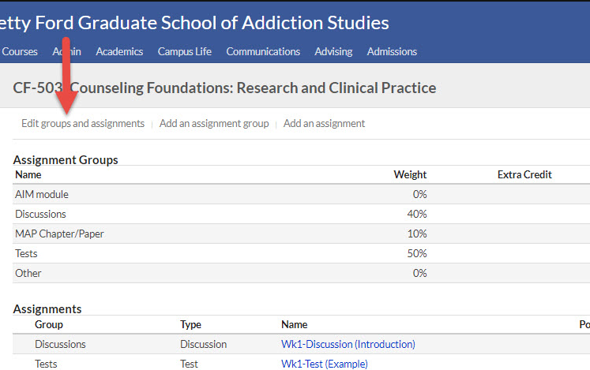
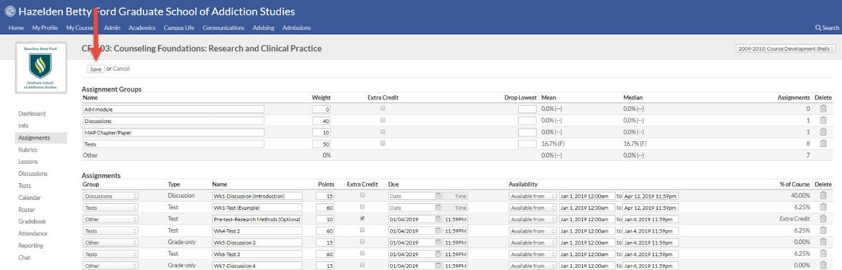

You can either delete the assignment when in editing mode or in regular mode. Click the trashcan icon under the delete column. Click "OK" to confirm deletion. Then, click "Save."
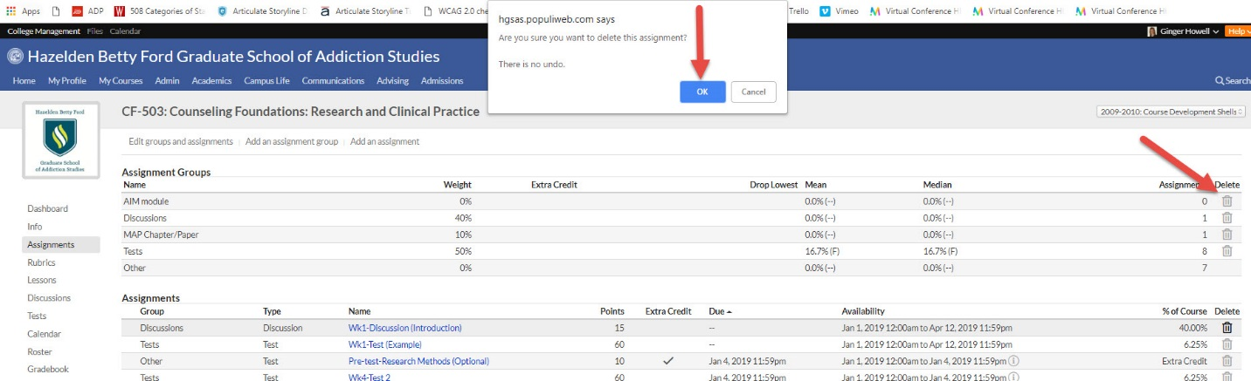
Now the assignment will appear in the Assignment tab, in the lesson, and in the gradebook.

