Warning-Objects not Inline

Accessibility Tutorial

May 10, 2019

Why Fix
Using certain formatting when inserting images or objects in a document will allow a text reader to read the content more easily.

Steps
- Click the specific warning in the Accessibility Checker. The object will be highlighted in the document.
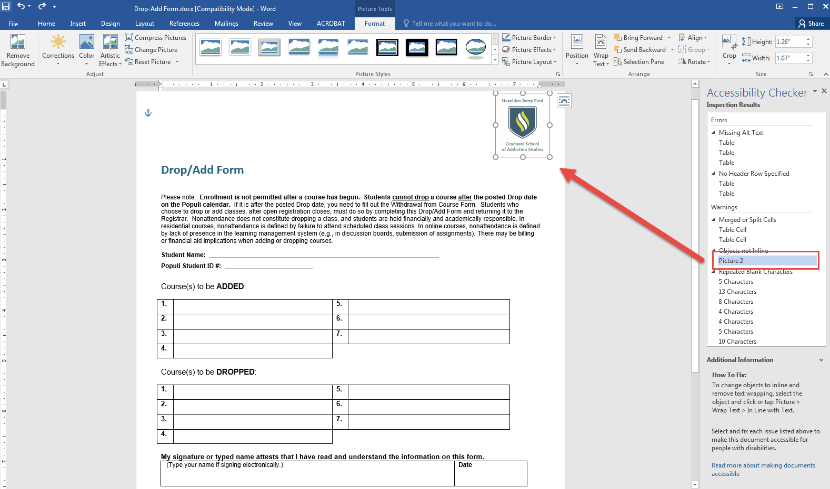

- Click the “Picture Tools” in the top, blue ribbon. Click the “Position” icon in the menu bar.
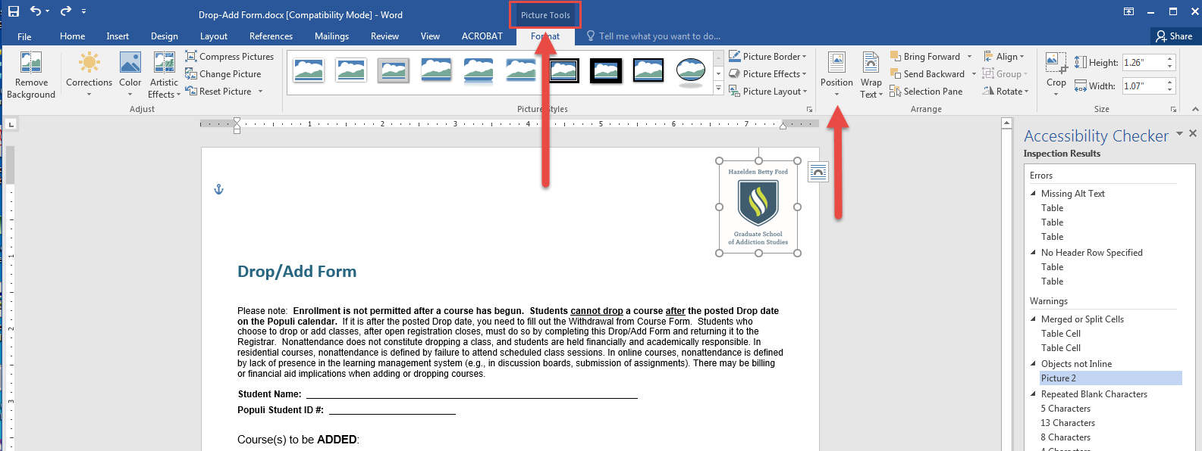

- A drop-down window will appear below. Choose the “In Line with Text” option. You know the warning is fixed when the issue disappears from the Accessibility Checker window.
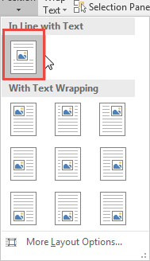

- The object may move, but it can be moved back to the original position if you use the top ruler.
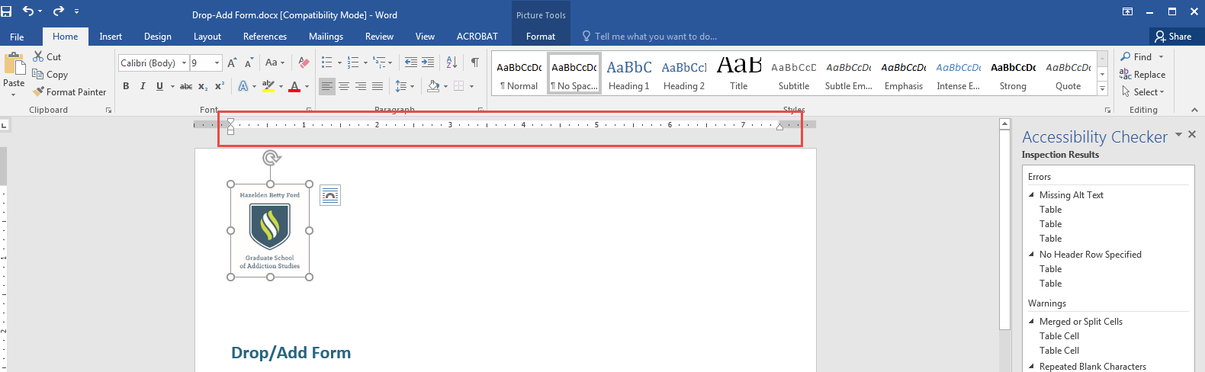
- Make sure to save the document.

