Warning-Table Structure and Merged or Split Cells

Accessibility Tutorial

May 10, 2019

Why Fix
When a screen reader describes the content of a table, it reads each cell from left to right and then up and down. If the table is not structured in way that can be read left to right, understanding can be hindered. Therefore, the table may need to be restructured.

Steps
There are two ways that the issue might be present.

I. Table Structure
- Click the specific warning in the Accessibility Checker. The first cell will be highlighted.
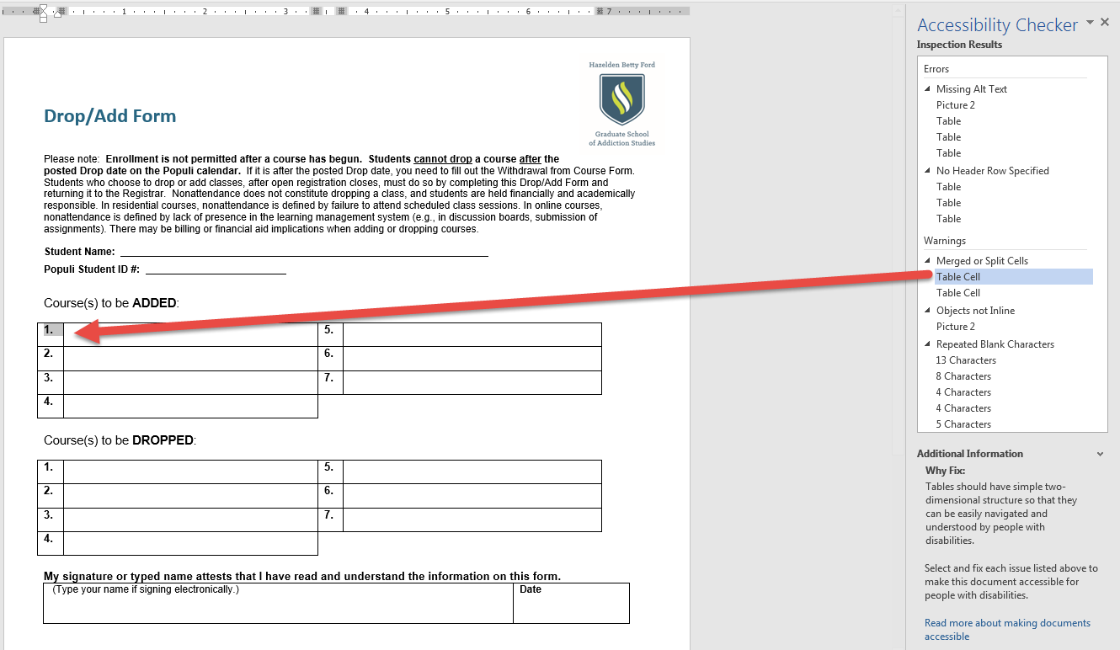

- Then, hit the tab key to make sure that the table makes sense when being read from left to right. The table below would need to be restructured because the reader would read 1., 5., 2., 6., 3., 7., and 4. when using the tab key.
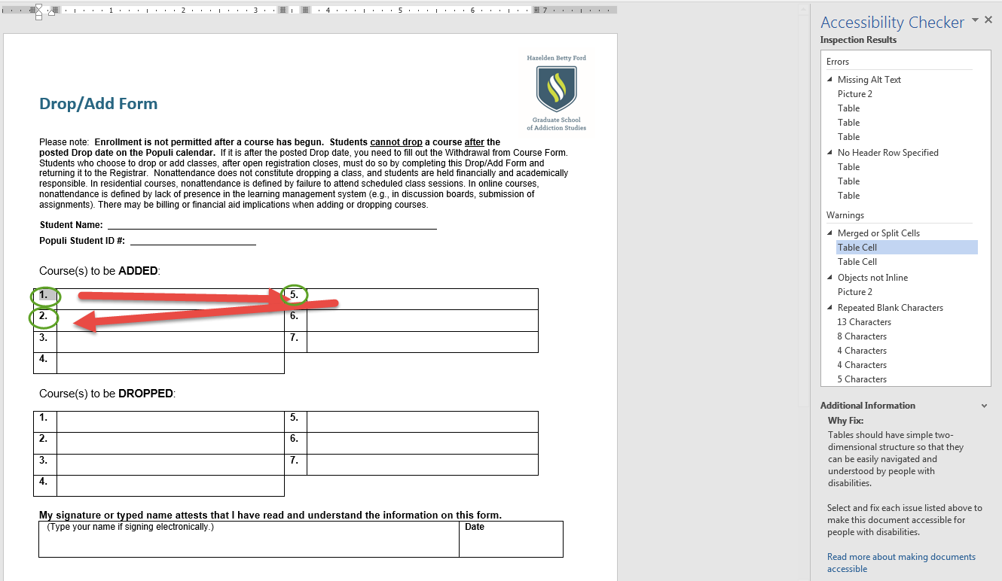
- After restructuring the table, save the document.
Please note that the warning will still show in the Accessibility Checker after it has been reformatted.

II)Merge/Split Cells
- Sometimes, the Accessibility Checker will identify an issue at the end of the table.
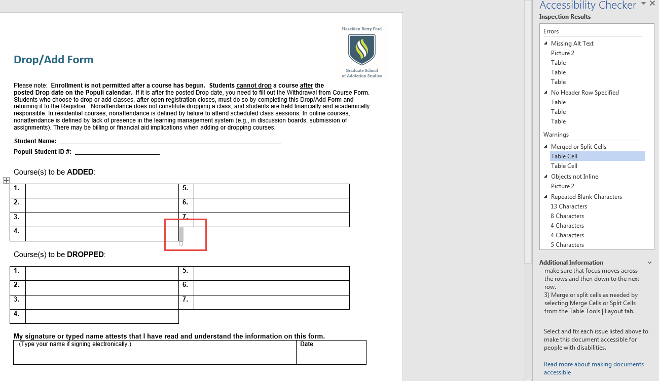
- Highlight the issue and the cell next to it. Click the “Layout” tab under Table Tools. Then, click “Merge Cells” or “Split Cells.”
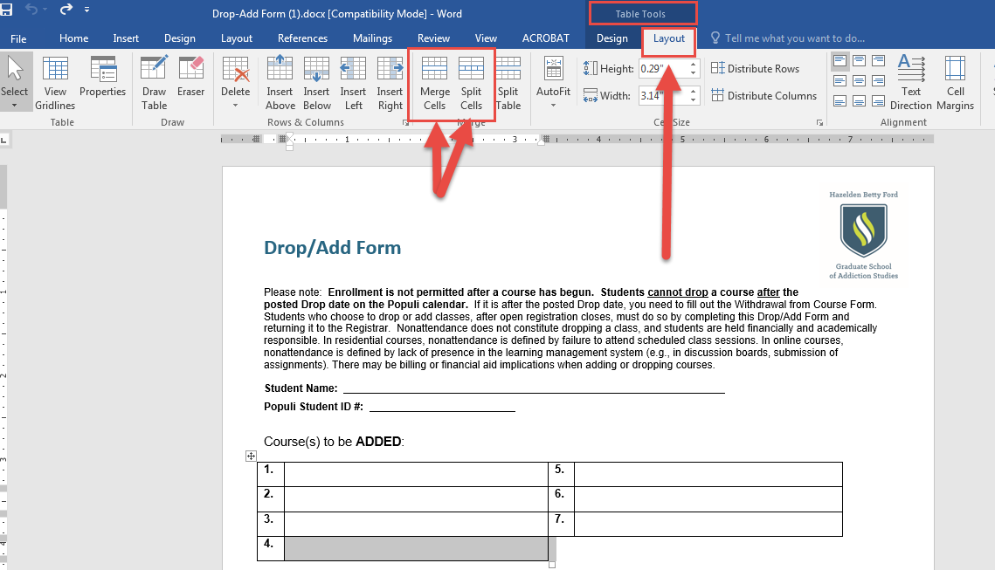
- Save the document.
Please note that the warning will still show in the Accessibility Checker after it has been reformatted.

