Tutorial-Retrieving Instructor Feedback

Populi

December 17, 2019

Introduction
Instructors leave feedback to 1) justify the grade the student earned and 2) to educate the student so that they can do better the next time they complete an assignment. There are different ways instructors leave feedback – feedback on your submission, feedback through comments in the submission area, feedback on the electronic rubric, and feedback in the viewer window.

Steps (Submission Feedback)
- If the instructor has left feedback on your actual submission, click on the instructor’s uploaded document located in the assignment submission area.
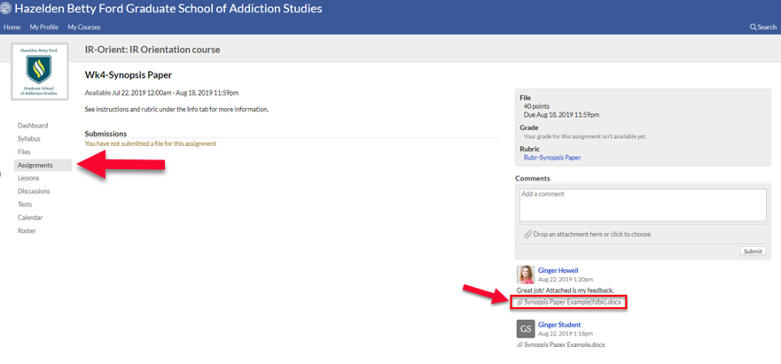
- In the upper right hand corner of the document, click the three dots. You’ll be given a pop-up window that will give you the following options:
- Download PDF
- Download Original Word Document
Chose to download the original word file. The document will be shown in a pop-up window or in your “Downloads” folder on your computer. You can open the document there, or drag and drop the document on your desktop.
- When you open the document, click the “Review” tab and, then, click “Show Comments” in the grey ribbon at the top of the document.
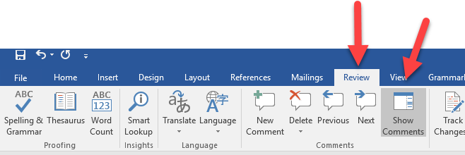

- View the comments to the right of the document.
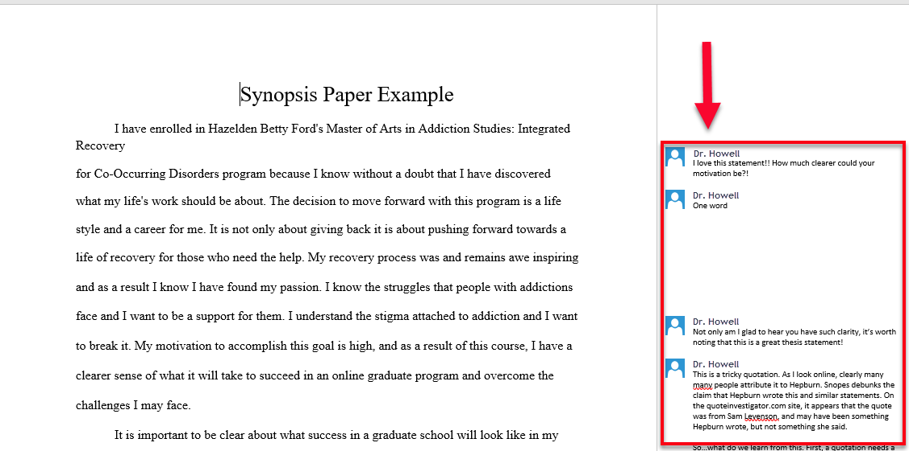

Steps (Comment Feedback)
- If the instructor has left feedback in the comment area, it will be located to the right-hand side. You can leave comments back to the instructor by typing in the textbox.
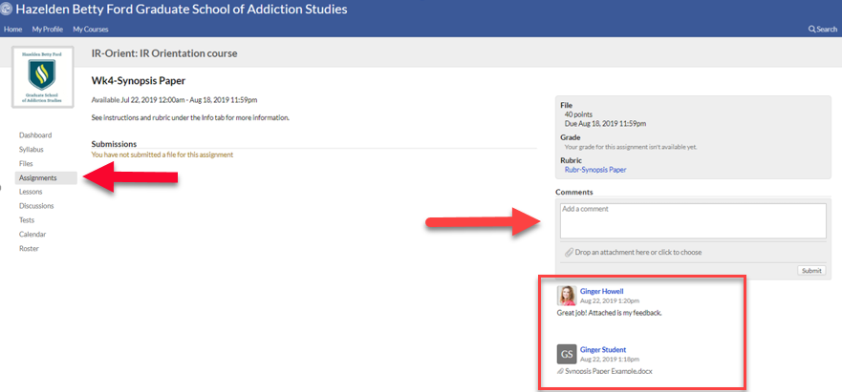

Steps (Rubric Feedback)
- If the instructor has left feedback in the electronic rubric, you can access it by clicking the rubric icon.
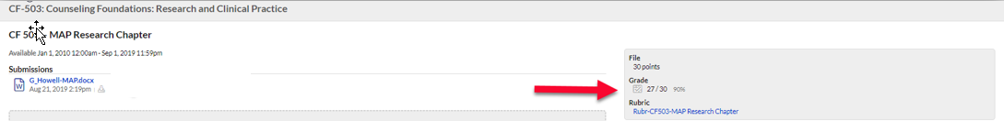

Steps (Viewer Window Feedback)
- If the instructor has left feedback in the viewer window, you can access their comments by clicking the speech bubbles. Please note that you cannot download and save the instructor’s comments if done in the viewer window.
