Accessing the Accessibility Checker

Accessibility Tutorial

May 10, 2019

Overview-
The Accessibility Checker is a feature in Word that will identify all the accessibility issues (errors and warnings) in the document. It will also explain why the issue needs to be fixed and how to fix it. Use the steps below to access the Accessibility Checker.

Steps-
- Pull up the document that needs to be made accessible and click the “File” tab in the upper left-hand corner.
- Click the box labeled “Check for Issues.”
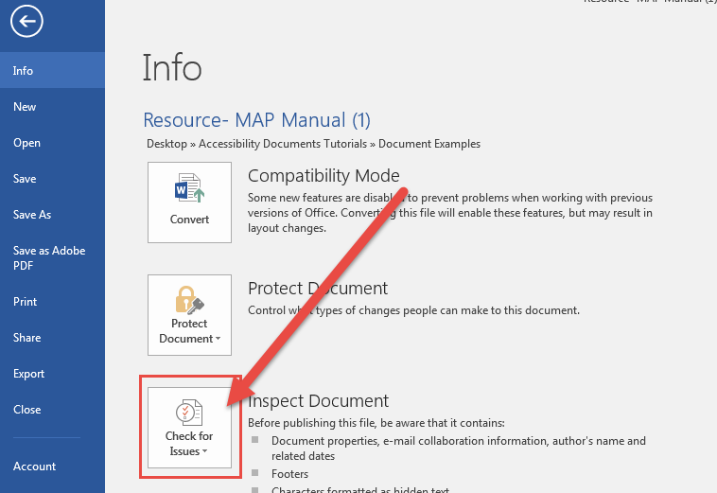
- A pop-up menu will appear. Click on the “Check Accessibility” option.
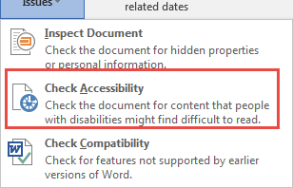
- The Accessibility Checker will slide out to the right of the document. The checker will identify each error and warning, describe why the issue needs to be fixed, and explain how the issue can be remedied.
