Guide-Logging onto Vimeo

Vimeo

May 14, 2019

Instructions
The Graduate School uploads videos to Vimeo in order to store, distribute, and protect the work done by those employed at the Graduate School. To respect our account contract, we can only have a small number on contributors that can access, upload, and share videos on Vimeo. If you need an account, please contact the instructional designer. Once the designer has given you access as a contributor, complete the following steps to log-on.

- Type in www.vimeo.com in the URL bar. Then, click “Log in.”
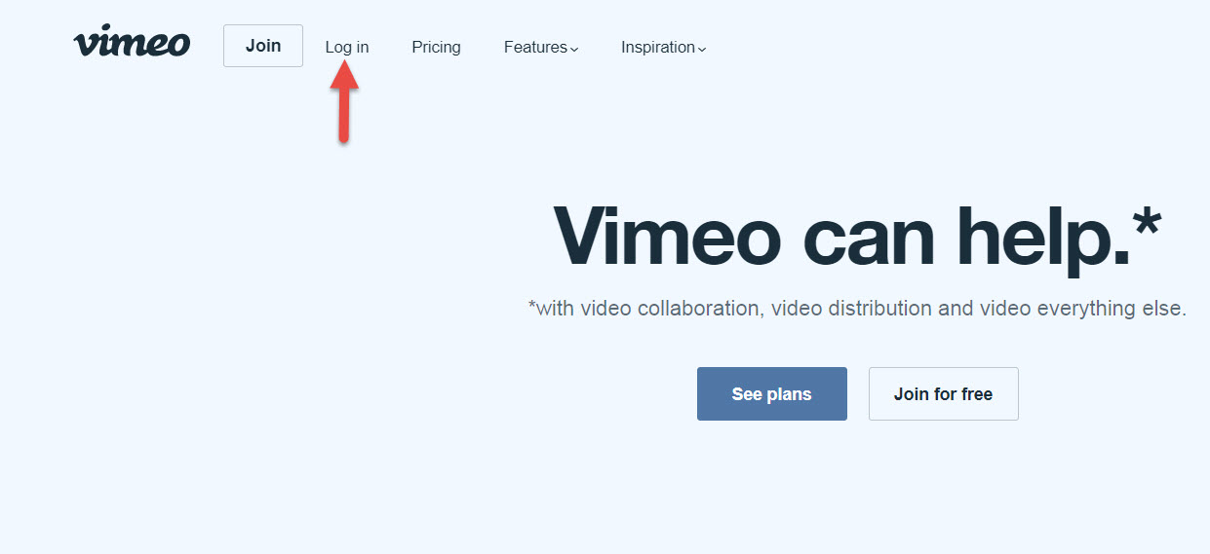
- If you don’t have a free Vimeo Basic account that uses your hazeldenbettyford.edu address, please create one by clicking “Join.” This needs to be done before you receive contributor rights. If you already have an account, please log in using your credentials.
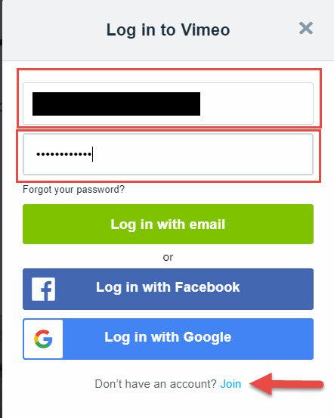
- Once you are in your own personal account (using your hazeldenbettyford.edu address), click the profile icon at the top right-hand corner. A dropdown menu will appear. Click “Change Plans.”
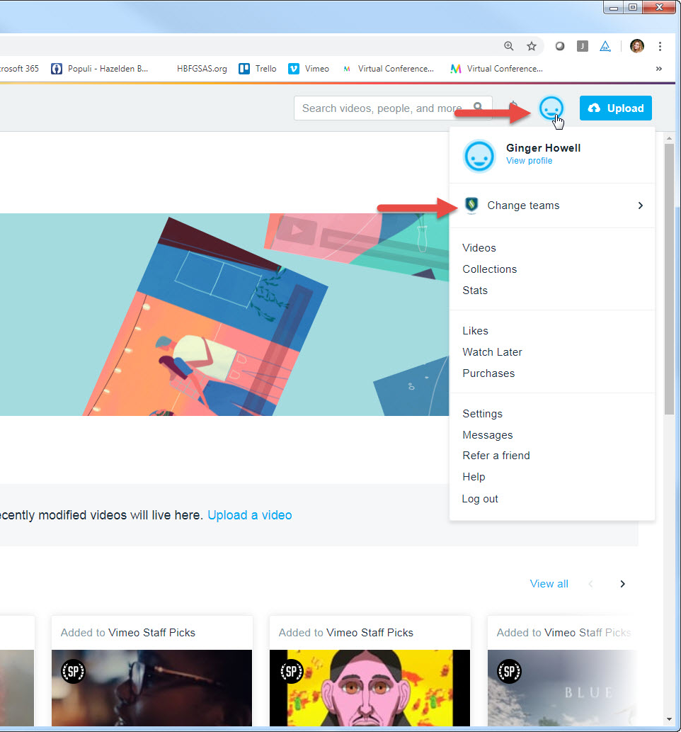
- Click the “HBFGSAS” option.
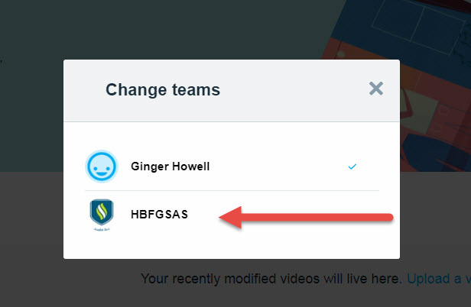
- Because you are given contributor rights, you will only have access to your folder. Click the folder and upload the video by clicking the blue upload button in the upper right-hand corner.
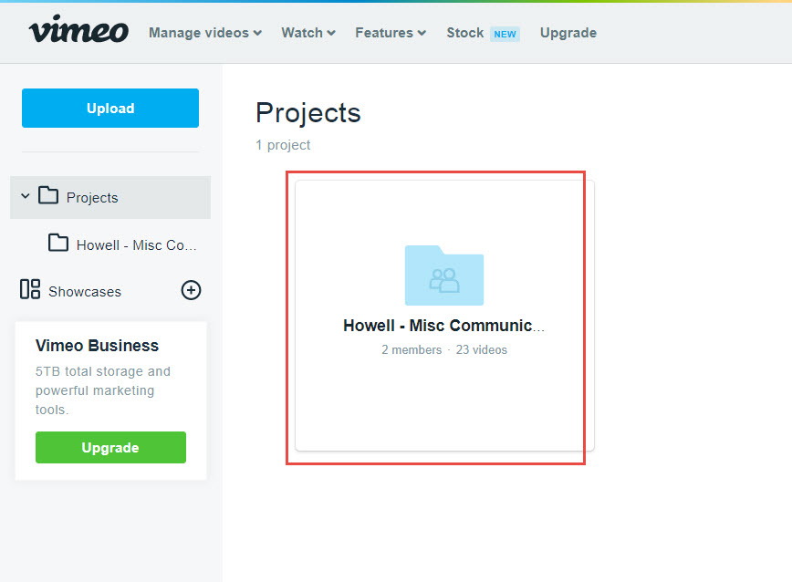
- From there, you can change share the link with others by clicking the link icon.

