Warning-Infrequent Headings

Accessibility Tutorial

May 10, 2019

Why Fix
Without the standard formatted headings, screen readers cannot identify topics for the reader. Additionally, headings aid in skimming.

Steps
- Click the specific warning under “Infrequent Headings” in the Accessibility Checker. Nothing will be highlighted because the issue will be within the entire document.

There is no good way to describe how to fix infrequent headings, and I wouldn’t change the headings unless I was the author. If I was the author, I would use the preset headings in the grey menu bar throughout the entire document. You can alter the font and size to make it visually appealing after you’ve used the preset headings. Once there is a good structure, the warning will go away.
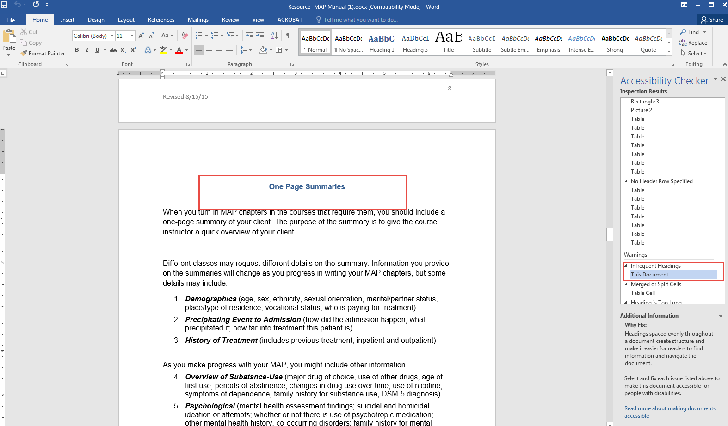
- Make sure to save the document.

