Tutorial-Update Populi Files

Populi

December 18, 2019

Introduction
Follow the steps to download the original Word file, delete the old file, and upload the new updated document.

Steps

Locate Document-
First, click on the document.
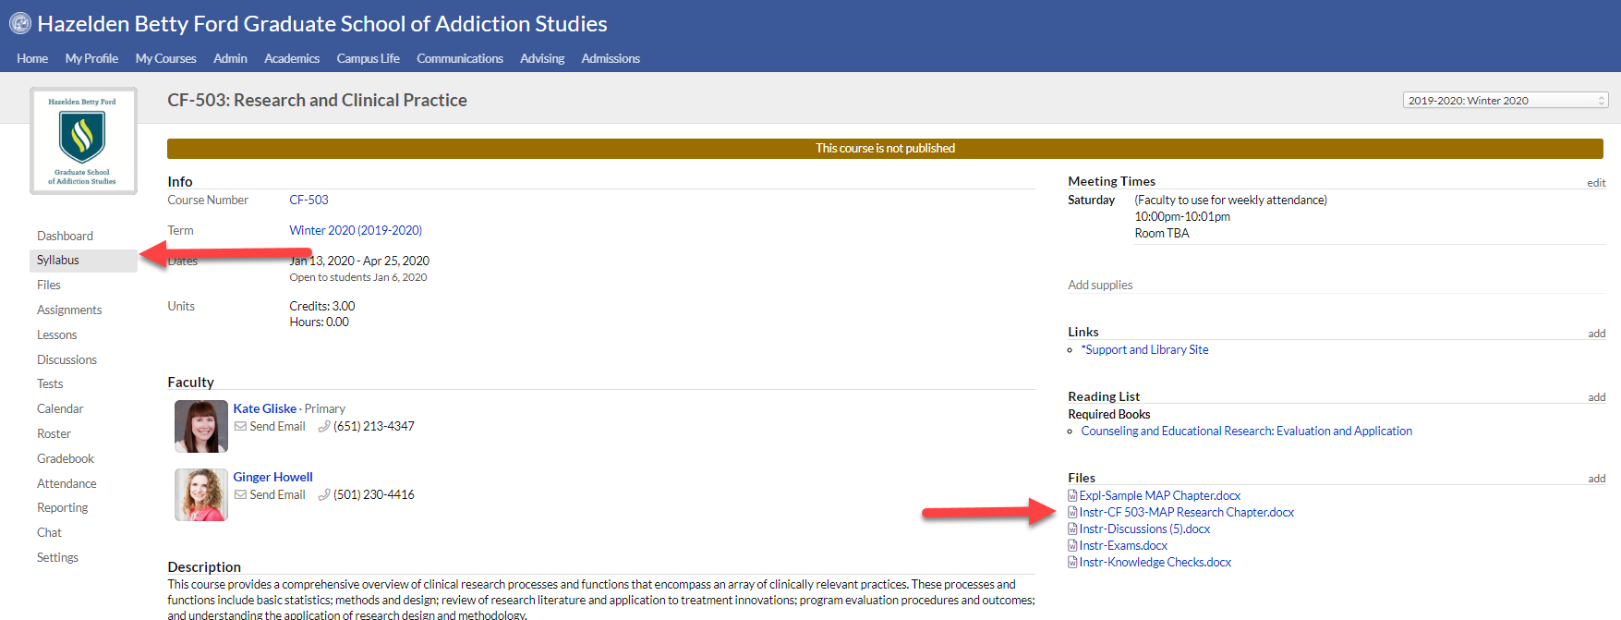
In the upper right hand corner of the document, click the three dots. You’ll be given a pop-up window that will give you the following options:
- Download PDF
- Download Original Word Document
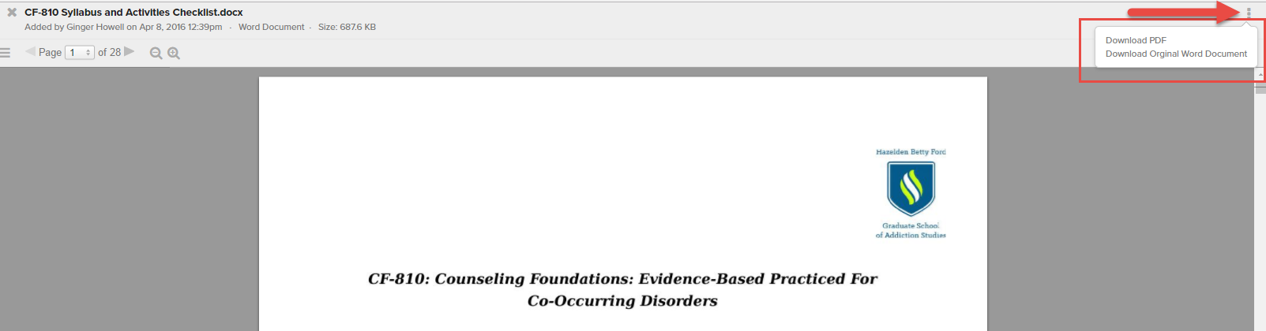

Download Word File-
If you chose to download the original word file, the document will be shown in a pop-up window. You can open the document there, or drag and drop the document on your desktop.
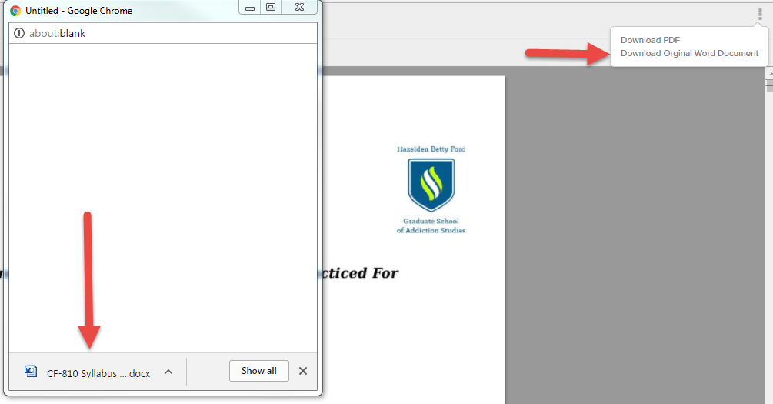

Delete the Old Document-
First, click on the document.
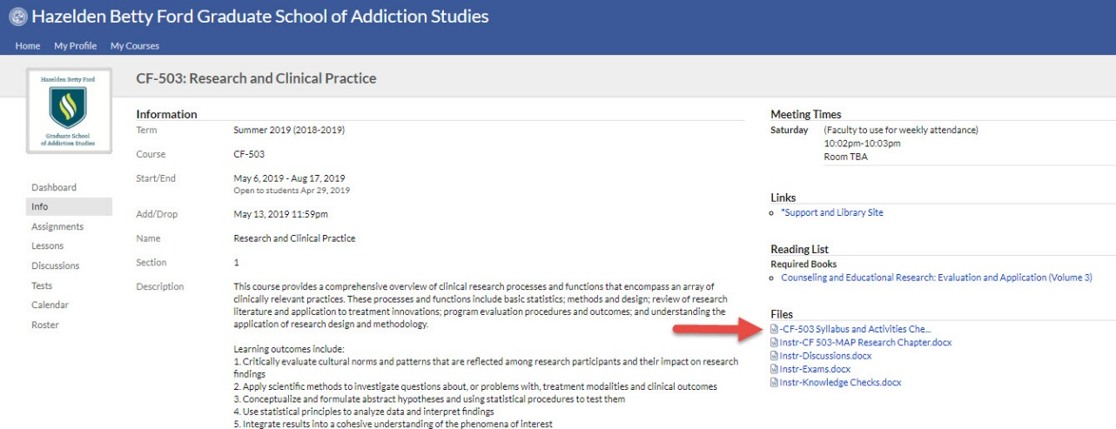
In the upper right hand corner of the document, click the three dots. You’ll be given a pop-up window that will give you the option to delete. Click delete and then confirm the deletion.
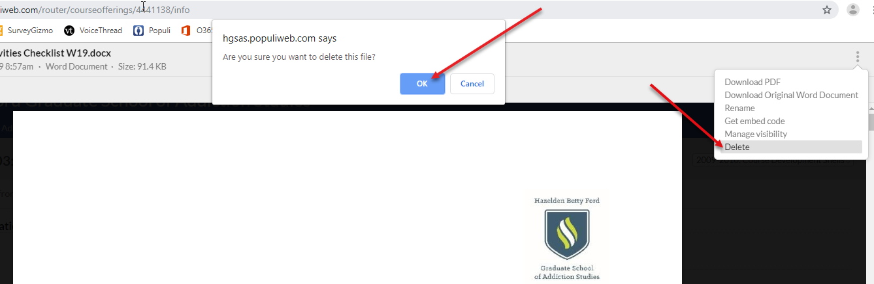

Upload the Word file-
To upload the new file, click “add” to the right of the Files section. Then, drag and drop the files into the pop-up window. Click “Done” when the files have been uploaded.
