Hello,  
  
As you prepare for classes, you will need to activate your Hazelden Betty Ford Graduate School of Addiction Studies email account. All official school correspondence should be addressed through your HazeldenBettyFord.edu email rather than your personal account.

To activate your Graduate School account, go to <https://outlook.office365.com/>

Enter your email address [____________@hazeldenbettyford.edu](mailto:____________@hazeldenbettyford.edu) and click Next:

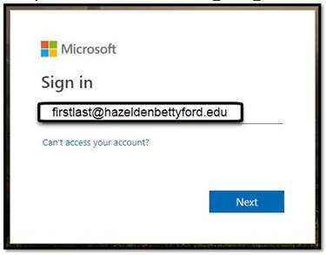

This should redirect you to the Hazelden Betty Ford Foundation Sign In page. Verify your email address and then enter your password and click Sign In.   
  
Your temporary password is **Chang3m3!** (Note the exclamation point is part of the initial password.)

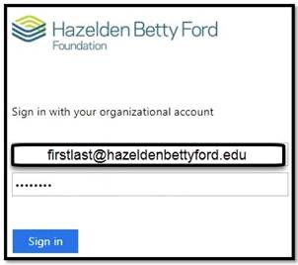

If the password is expired, which it usually is for new users, you will be sent to an Update Password screen. Verify your email address and then enter the initial/old password (**Chang3m3!)** and then set and confirm your new password.

**Passwords must be at least 8 characters in length and contain characters from three of the following 4 categories:**

* **Uppercase characters**
* **Lowercase characters**
* **Numerical characters 0-9**
* **Special characters** [**~!@#$%^&*_-+=`|\(){}[]:;"'<>,.?/**](mailto:~!@#$%^&*_-+=`|\(){}[]:;"'<>,.?/)

Click Submit.

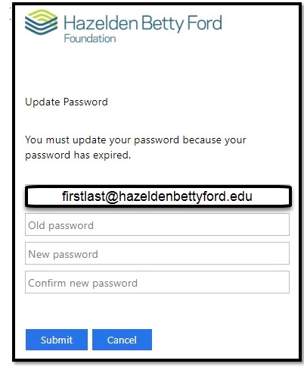

Now you will be returned to the Hazelden Betty Ford Foundation Sign In screen. Verify your email address and enter your new password.

Click Sign in.

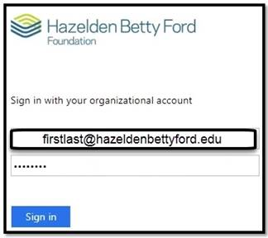

As soon as you have successfully logged in, please send me an email from your Graduate School email account so I know you were able to complete this task.   
  
If you ever forget your password or need email assistance, contact Technology Services at 1-651-213-4785. I recommend jotting this number down so it is accessible if you cannot login to your emails.