Tutorial-Creating Exams

Tutorial

December 26, 2019
There are multiple aspects to tests. In this tutorial, the following will be explained:
- How to prep your test
- How to create a test
- How to make edits
- How to add exceptions

Prep Work
First, go to the Assignments tab of your course and click “Add an Assignment.” Make sure you fill in the necessary information in the Pop-up window.
- Make sure “Tests” is filled in for the type. This will allow you to create a window of time to allow students to take the test.
- The availability window should be between 3-7 days. This will allow students the flexibility to take a test.
- You may or may not choose a time limit for the test, whether students can access or take the test more than once, and if or when the answers are available to students.
- Make sure you think about the implication of all the settings. When you consider if students should have a time limit, the amount of retakes, and if answers are available to students, keep in mind ways you can limit and discourage cheating on the exam.
- Click “Save.”
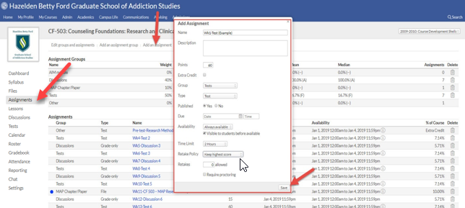

Create the Exam
Now you are ready to create the exam! Go to the Tests tab. Click the exam you just created.
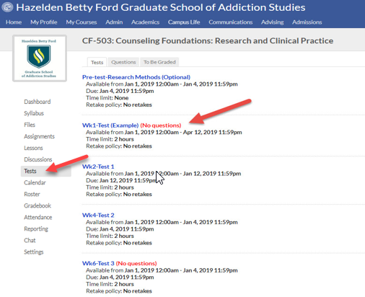
You may want to start with a heading or directions to the exam.
If so, click the words “heading” or “some text." Create the content and click “Save.”
Then, start adding questions by clicking the blue “question” link. Most of the time, you’ll create a new question, so use the drop-down menu and choose “new question.” Choose the type of question you want. You can choose from multiple choice, short answer, put in order, multiple answer, essay, true/false, and matching questions. Then, fill in the information. When you are done, click “Save.”
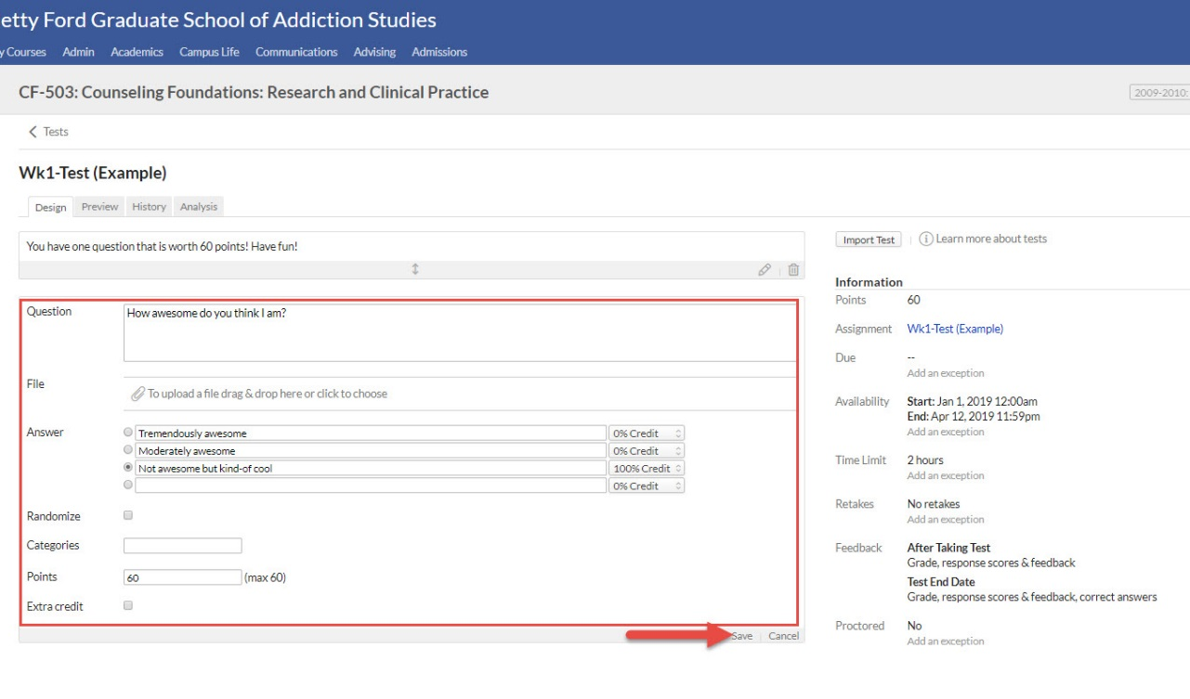
As you continue to create the exam, make sure to allocate all the points. If you have unallocated points remaining, the test will not show to students. Also, you should note that questions that have answer choices are automatically graded by Populi. Answers that are subjective, such as essay questions, have to be graded by the instructor. If questions have to be graded by the instructor, students will not receive a grade until the instructor grades those questions.
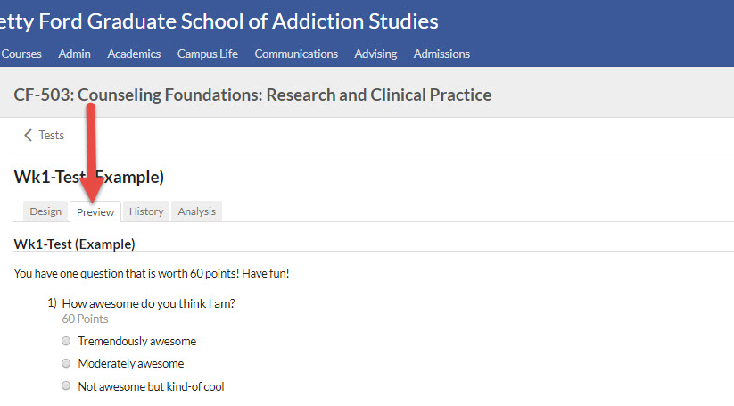

Edit the Exam

Content-
Once you are finished creating the exam, you can preview the exam in the “Preview” tab.
You may need to edit a question. To do so, go back to the “Design” tab and locate the question, and click the pencil to edit. Make and save the changes.

If the question has been used in a test in another term, Populi may tell you that you can’t change the question. If this happens, the best way to handle this is to delete the incorrect question and create a new version of the question. There is no easy way to edit a question once it has been use. Then, click “Save.”

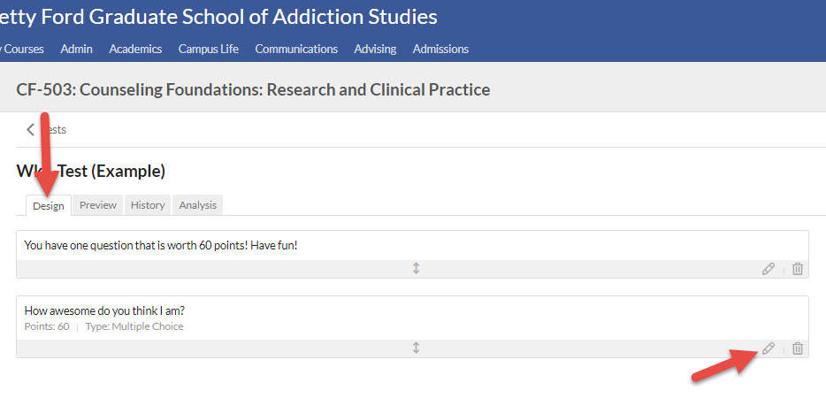

Settings-
To edit the settings of a test, first go to the Assignments tab and click the test.
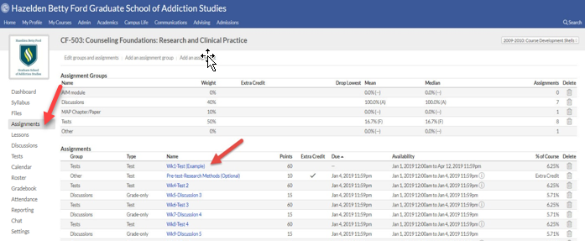

Then, off to the right-hand side, you’ll see the information for the test. Click “Edit.” Alter the information and click “Save.”
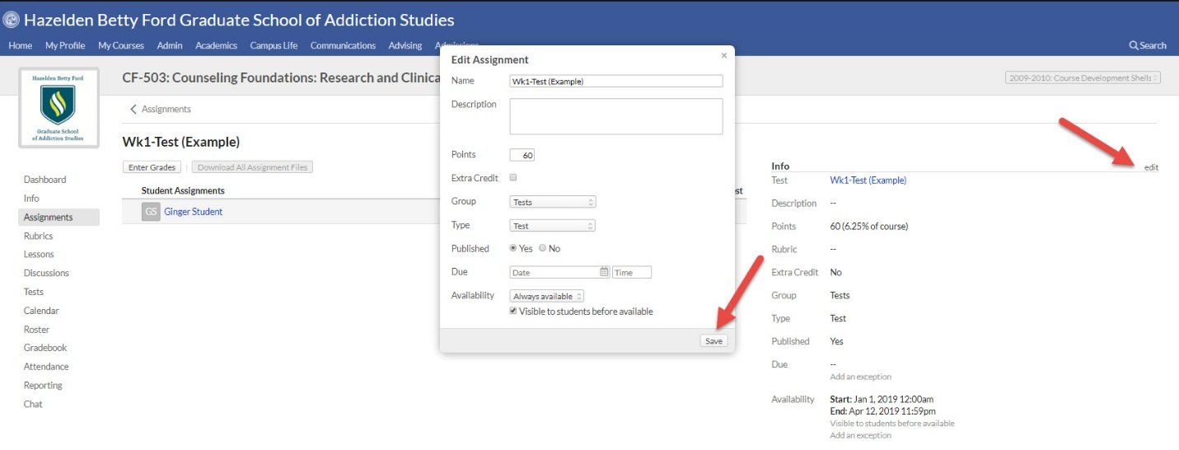

Adding an Exception
There may be times where a student will need an exception compared to other students. Adding an exception is easy. First, access the exam in the Tests tab. Off to the right-hand side, you’ll see “Add an exception” under the due dates, availability dates, time limit, retakes, and proctoring requirement. Click the setting in which the exception needs added. Then, alter the information.

