Taking a Test and Reviewing Feedback

Populi

January 19, 2019

Introduction
In your online courses, you may be required to take a test to assess your current knowledge. This tutorial shows how to take a test and review the feedback after the test is over.

Taking a Test
You can access tests by clicking the Tests tab. The Tests tab will list all exams that you have access to or have had access to in the past. Usually, the instructor will make the test available for about 3-7 days before the exam closes. You will be able to take the exam during that window of time. Under the exam name, you will see the details of the exam, such as when it is available, the time limit in which you need to complete the exam, if any retakes are allowed, and if answers are available to you after the exam.

When you are ready to take the exam, click “Take now.”

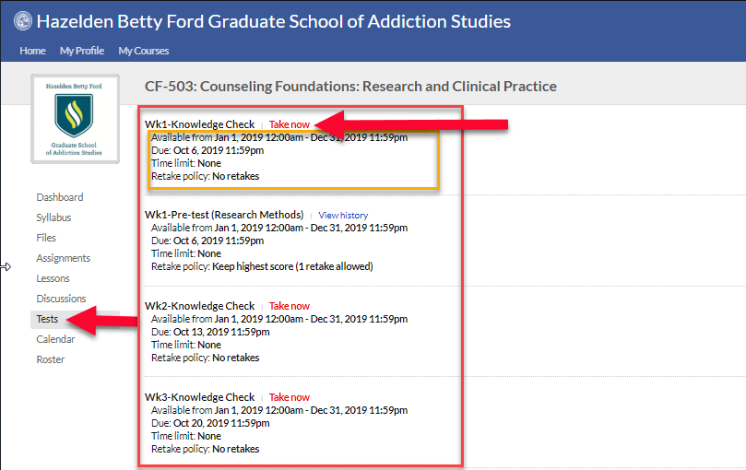

Then click “Click here to start the test.”

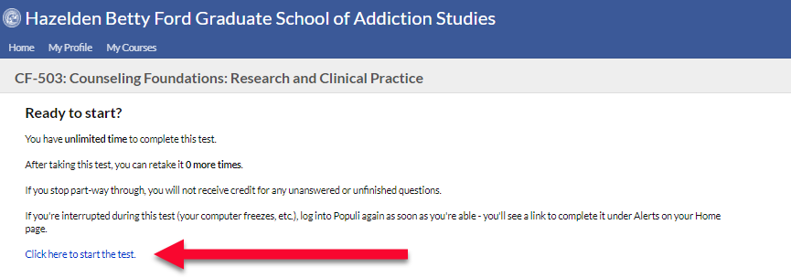

Take your time to answer the questions. If you click the text and not the circle, Populi will fill in the circle for you, whether you wanted to select that answer or not. So be careful when you scroll.

You will see how many points the question is worth under the test question. Once you answer the question, you will see that it is saved.

When you are done, click “Submit Test.”
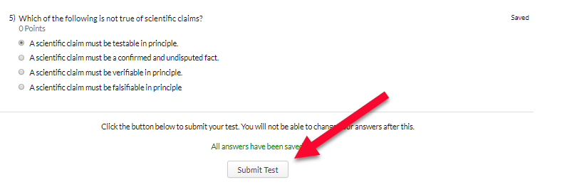

You will receive a message letting you know that you’ve completed the test and the score you have earned.

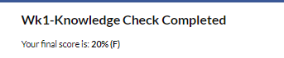

Reviewing Feedback
Sometimes you can view the answers to your test after you’ve finished the test or after the accessibility date when everyone has had the chance to complete the exam. To receive feedback, click the Tests tab to the left-hand side in Populi. Click “View History” of the exam you’d like to review.
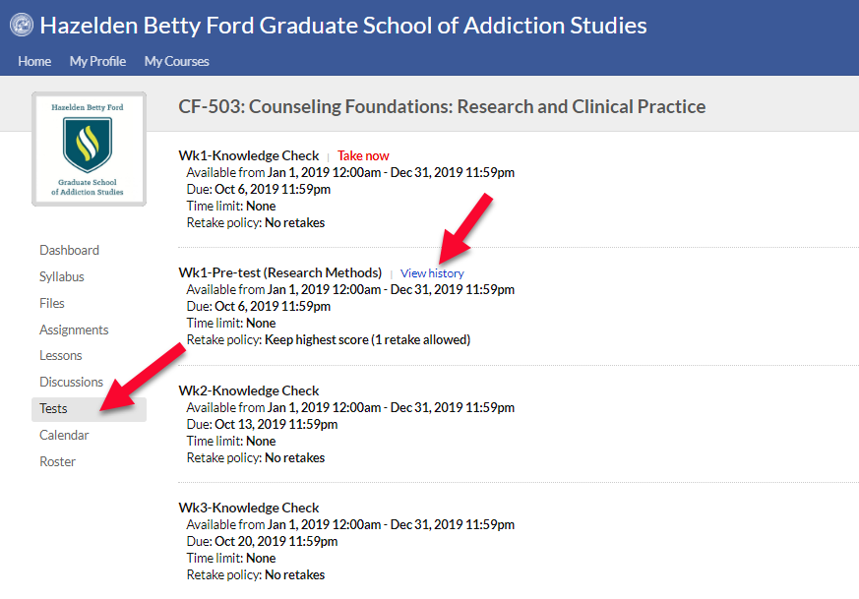
Then, click the date that you took the exam.
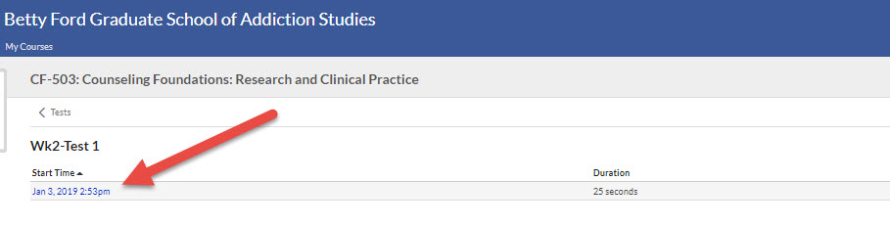

The questions, answers, and instructor’s feedback will be under each question.
