Tutorial-Joining a Zoom Meeting

Populi

April 28th, 2020

Instructions

- Click the “Meeting Room” link in the presentation area.

- Then, click ‘Open Zoom Meetings.”
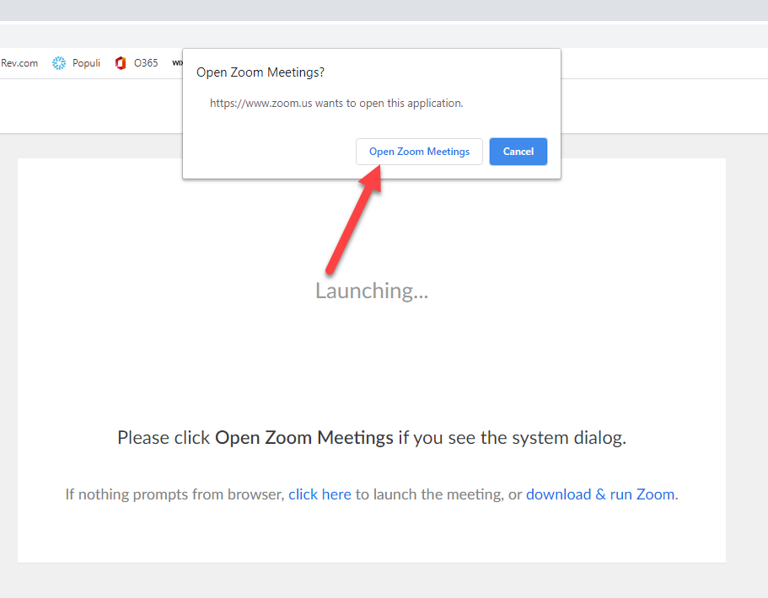

- If asked, input the password located in the presentation area.

- In the pop-up window, click the “Call Me” tab. In the box, put in your phone number. Check “Remember the number on this computer.” Then, click the “Call Me” button. Your cell phone will ring. Answer the call and you will join the meeting.
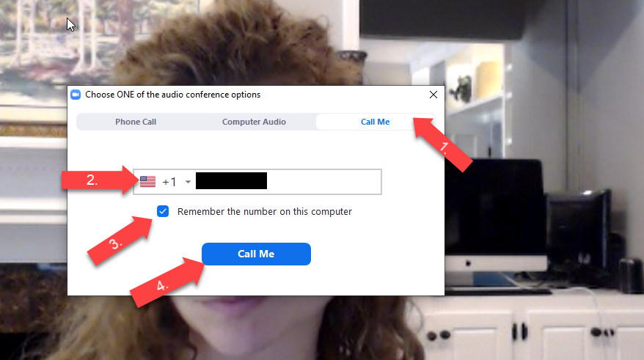

- Then, connect your video by clicking the camera icon in the bottom left-hand corner. You may need to click the small arrow to the right of the icon and choose the specific webcam if you have both an external and built-in camera.
