Tutorial-Accessing a New Term

Guide

January 18, 2019

Most Common Method
Once you become a seasoned instructor or designer at the Graduate School, you might need to access a specific course in another term.

To do so, log into Populi and find your Home page. Locate the “Courses” section to the right side. It will usually be set to show your current courses. However, if you want the list of your courses to reflect a different term, click the drop-down menu and find term you want and click it. Then, choose the class you want to open.
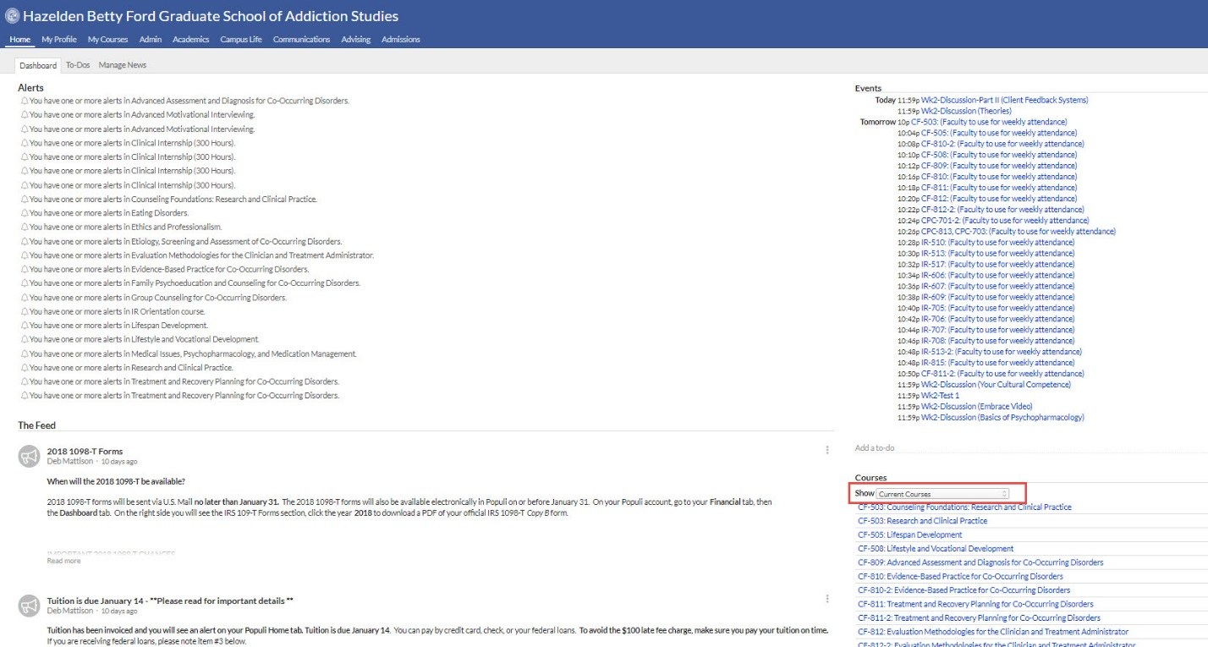

Alternative Method

Let’s say you are already in a course and want a different semester. All you have to do is access the drop-down menu in the upper right-hand corner and select the term of the class you desire.
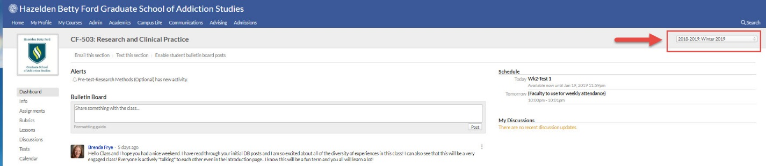

That is how you change terms in a course.

