Tutorial-Taking Attendance

Populi

December 17, 2019
Each week, instructors will need to make sure students have participated at least once. On Monday morning, you’ll take attendance for the previous week.
First, click on the classroom button on the top right hand corner. 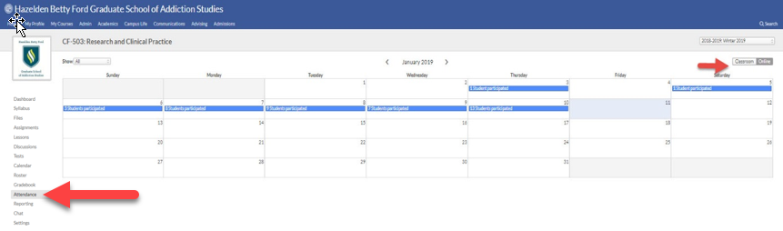
Then, click previous week’s attendance section, which is a purple box.
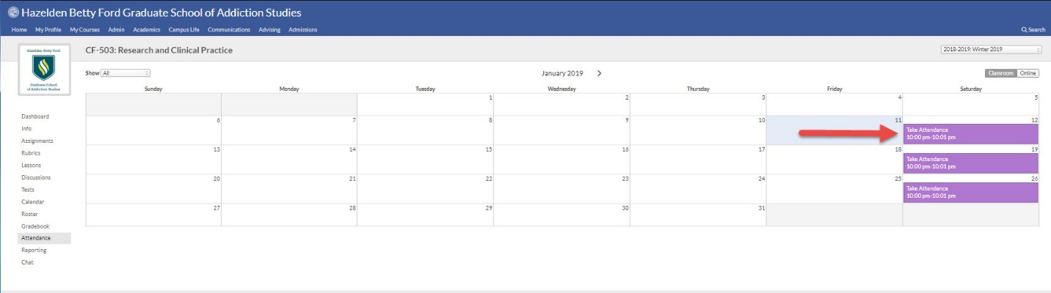
Next to each student’s name, you’ll be able to mark if they are present, absent, tardy or excused. When you are finished, click “Save Attendance.”
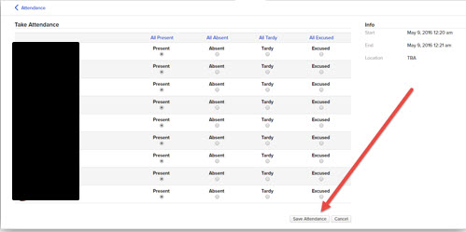

Tip:
In order to make attendance taking a little faster, do the following:
In another browser window, open up the Attendance tab again. Each blue stripe is a link.
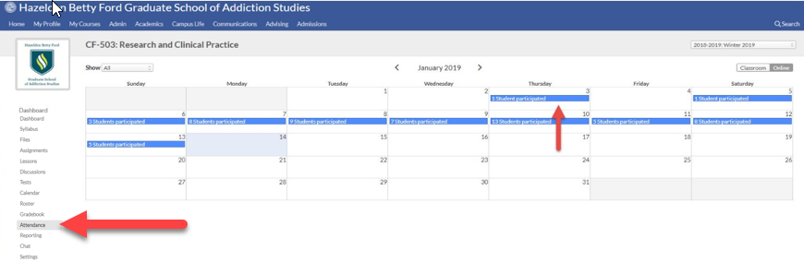It will bring you to a list of students in that course that day. Additionally, you’ll see a link entitled “Detail.” When you click the link, Populi will list how that student participated and when. If you want to see how they participated, click the link that describes the participation. It will take you directly to that part of the course. This will allow you to quickly see who was present each day.
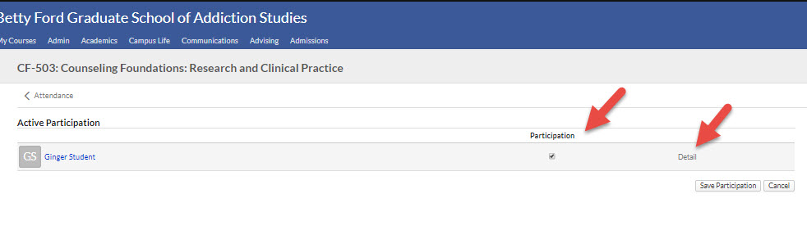
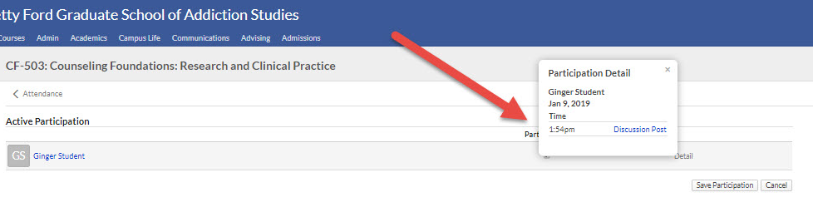

When you are done taking attendance, make sure to save your work!

