Warning-Heading Too Long

Accessibility Tutorial

May 10, 2019

Why Fix
Short concise headings make it easier for people to quickly navigate the document structure either by skimming or using a screen reader.

Steps
- Click the specific warning in the Accessibility Checker. The text that has been formatted as a heading will be highlighted.
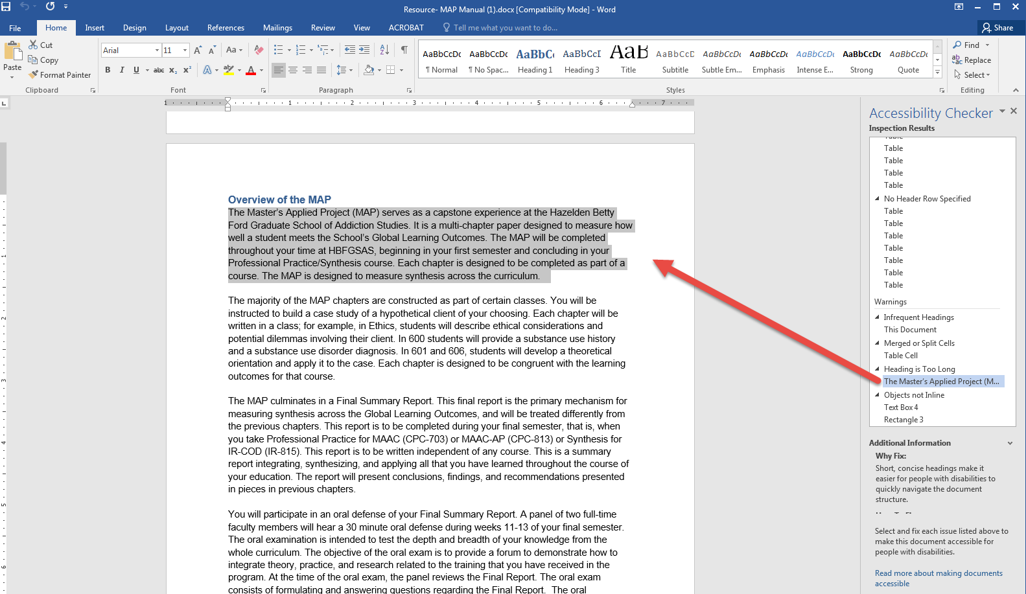

- Click the “normal” text icon in the grey, top menu. When the warning is corrected, it will disappear from the Accessibility Checker.
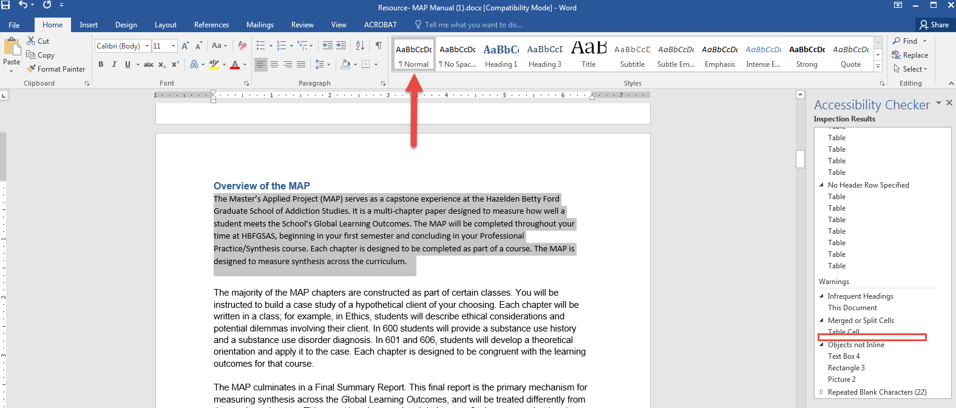
- Make sure to save the document.

