Tutorial-Create a Video/Audio Recording

VoiceThread

August 17, 2022
To create a video or audio presentation without slides, log in to your account. Click “Create” in the upper right-hand corner. Click “Add Media.”
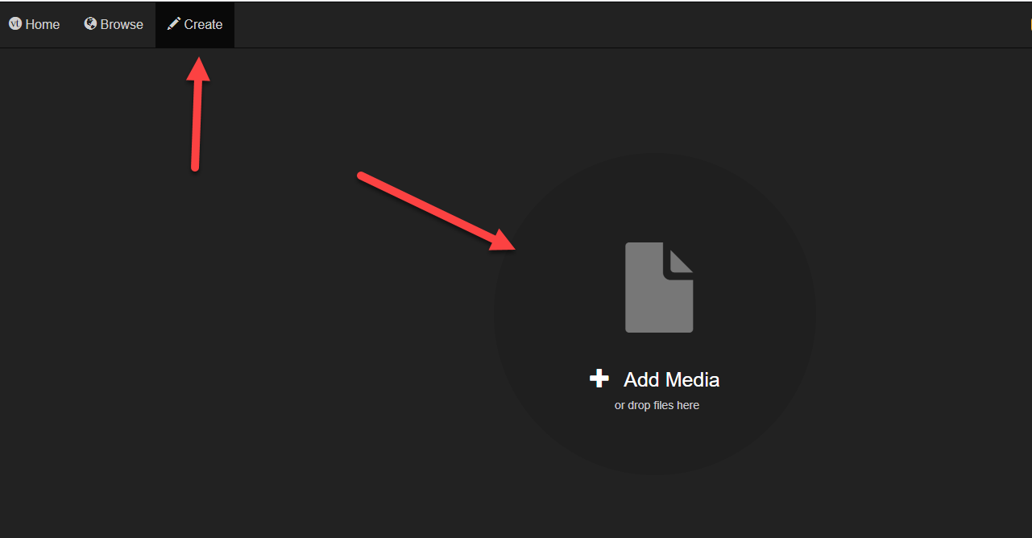
You’ll be given a menu. Click either “Audio Recording” or “Webcam Recording.” Then, do your recording. Click “Stop Recording” when you are finished.
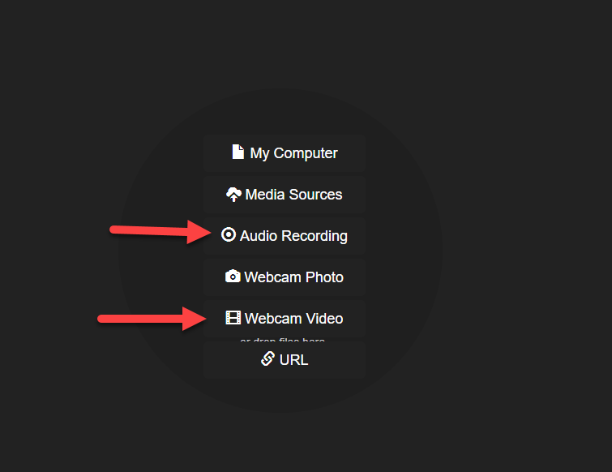

Keep in mind that this method does not narrate your slides but creates a different type of presentation.

