Warning-Repeated Blank Characters

Accessibility Tutorial

May 10, 2019

Why Fix
Use formatting, indenting, and styles to create whitespace instead of repeating blank characters, since blank characters will make it difficult for the text reader.

Steps
- Click the specific warning (# characters) in the Accessibility Checker. The blank characters will be highlighted.
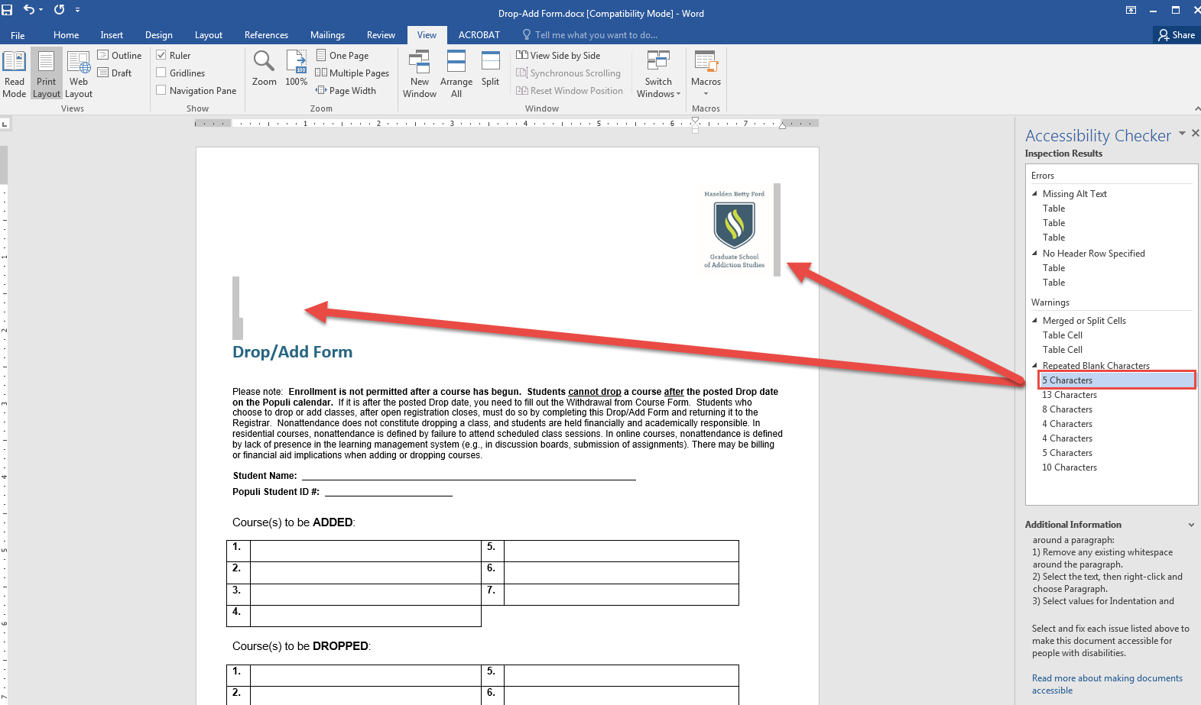

- Click “Delete.” You may need to manipulate the layout manually (add a space or hit the enter key) to restore the visual aesthetics.
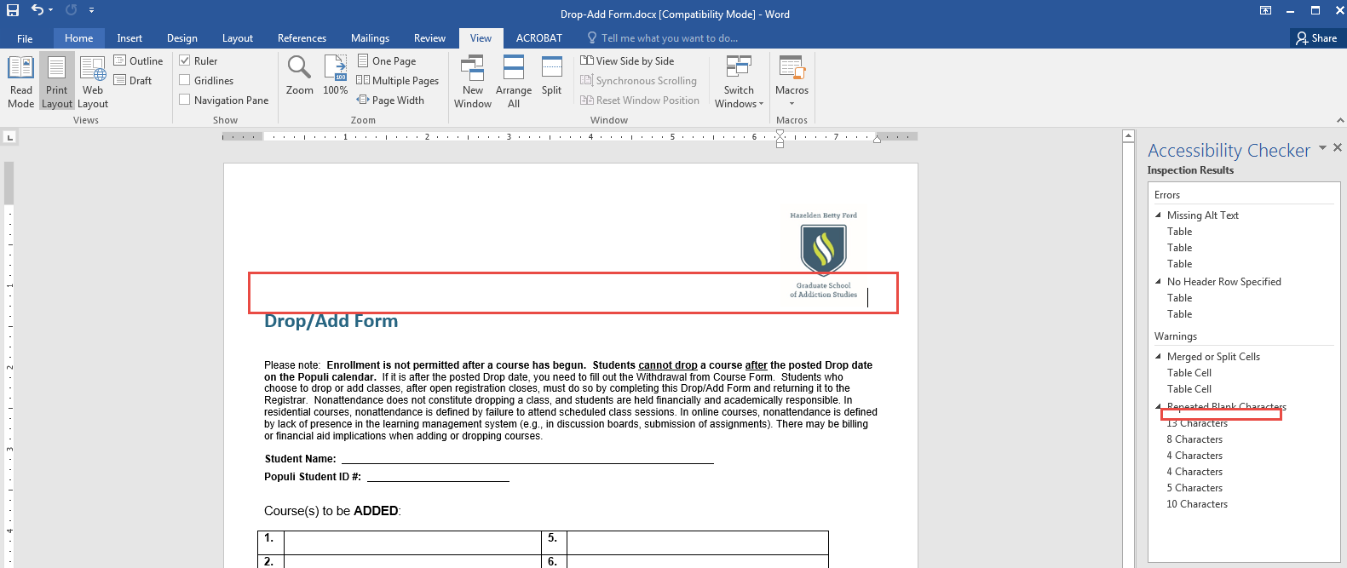
- Make sure to save the document.

