Error: No Header Specified

Accessibility Tutorial

May 10, 2019

Explanation-
A table header row contains column headings that provide context and aid navigation of the data in the table. The header is important in understanding the organization of a table. Imagine reading a long table that spills over to the next page. In the middle of the table, you may forget what a specific row represents and have to scroll up to the header to verify what meaning the cell is conveying. When a row is designated as a header, two things will occur - 1) The screen reader will identify the row as a header 2) will repeat the header if it spills onto the next page so that the reader doesn’t have to scroll to the top to understand the table.

Steps-
- Click the specific error in the Accessibility Checker. The top header will be highlighted.
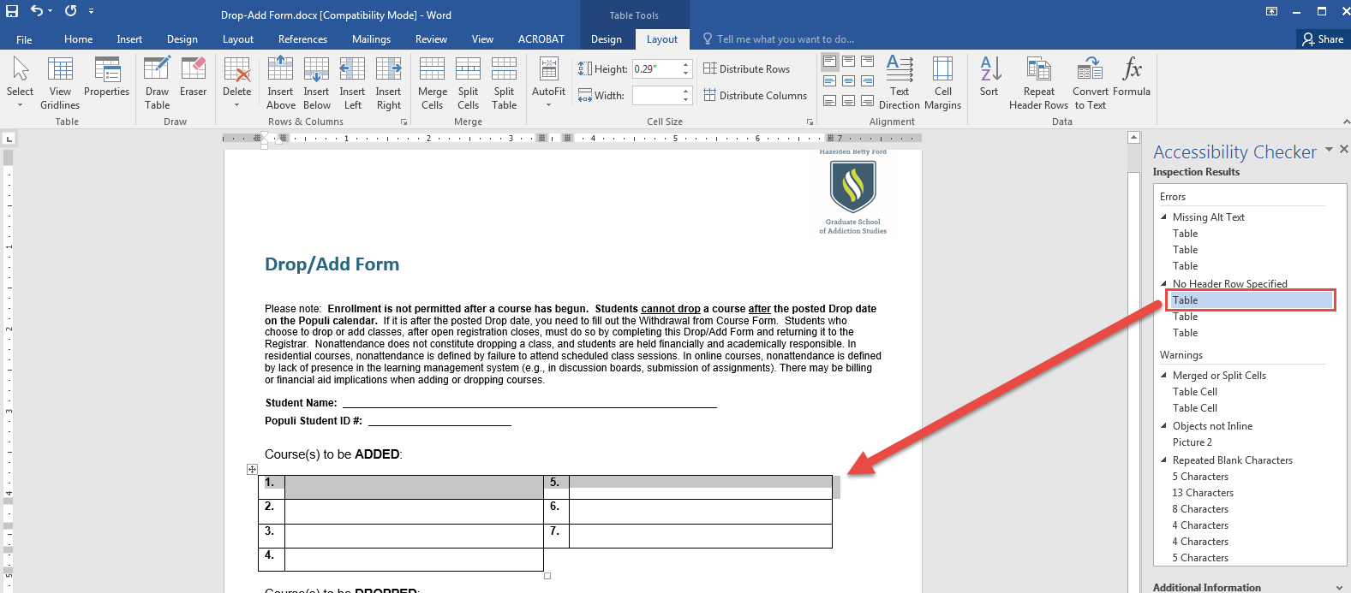
- Click the “Layout” tab under the “Table Tools” in the top, blue menu. Click “Repeat Header Rows” and the error will be fixed. You know it is fixed when the error disappears from the Accessibility Checker window.
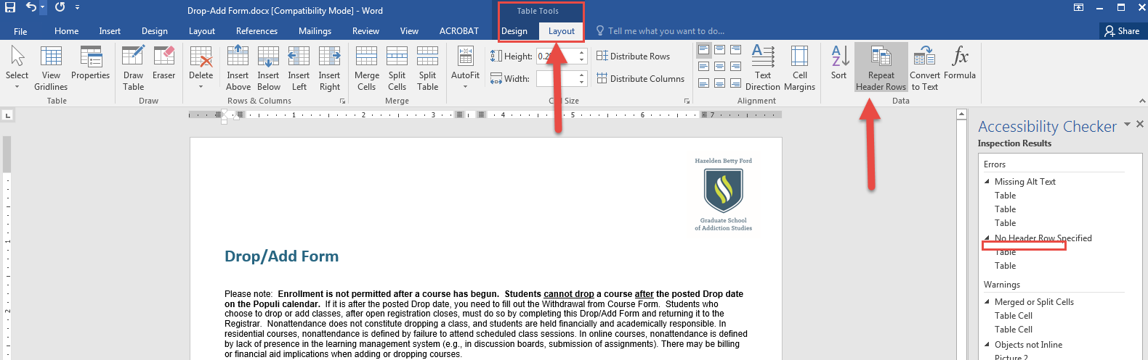
- Make sure to save the document.

Please Note:
Please note that if the Accessibility Checker can’t open with a specific document, make sure that it is has a more updated extension, such as a .docx versus a .doc. Also, the Accessibility Checker will not work on PDFs; therefore, documents need to be made accessible before made into a PDF.

